**Multidisciplinary Topology Optimization of Hot Structures Subject to Random Engine Acoustic Loading**

Topic Area: RQ16-36: Aerothermoelastic Analysis Methodologies for Aircraft Design

AFRL POC: Dr. Philip S. Beran

*Student*: **Admir Makas** (primary author)

*Advisor*: **Dr. Ramana Grandhi**

Wright State University

**Problem Statement**

Ever since the advent of turbine engines, acoustic loading of the adjacent structures has been noted as a significant source of fatigue damage, which tends to reduce the intended life of affected components. As early as the 1950s, random acoustic loading was identified as a critical parameter that warrants consideration in the early stages of aircraft design. Despite this observation, acoustic loads have received little attention in the preliminary design stage. This is attributed to the complex nature of the dynamic problem that is inherent in an acoustic-related analysis, which can make the analysis both computationally demanding and time consuming. Additionally, acoustic loads are considered low in magnitude with respect to structural loads imposed by aerodynamic and thermal effects. Regardless of their small loading magnitude, the severity of acoustic loading is amplified by the multi-physics nature of the aircraft loading environment, which is not typically considered in the preliminary design stage. As a result, over the past 70 years, there have been notable fatigue-related issues as a direct consequence of poor acoustic considerations. To remedy the impact of these early failures, substantial monetary and time expenditures are often required in terms of unplanned inspection and repair intervals.

As aircraft designs become increasingly complex due to stealth and high-speed flight requirements, the role of acoustics will increase and must be treated with a novel and multidisciplinary approach in conjunction with aerodynamic and thermal loads. This is especially true for tailless Efficient Supersonic Air Vehicles (ESAV) and the accompanying Engine Exhaust Washed Structure (EEWS), which is often found in embedded engine aircraft design. These structures are exposed to random acoustic and thermal loading that causes a non-linear structural response composed of local and global buckled modes, which are not well understood. Lack of high-fidelity physics in early analysis led to early skin failures on the upper wing section of the F-15 fighter, which is a generation 4 aircraft. This issue was propagated to later generation aircraft such as the B-2 spirit stealth bomber, where the aft-deck of the embedded exhaust structure fails prematurely due to a combination of acoustic and thermal loads. The above examples clearly demonstrate a need to develop a better physical understanding of the loading interactions within the embedded exhaust structure. More specifically, the work proposed herein aims to employ an FE modeled coupled fluid-structure model of the exhaust structure to accomplish the following tasks:

* Incorporate heat transfer analysis of the coupled fluid-structure EEWS model to ascertain the temporal distribution throughout the structure.
* Use the temperature distribution results to obtain the thermal response of the EEWS structure. Following this, perform modal analysis on the fluid-structure model to determine the dynamic response and the coupling nature of the fluid and structure components. At this stage, model fidelity levels are also investigated.
* Utilize modal analysis results in conjunction with periodic and random loading to investigate fatigue implications of the structure due to panel buckling phenomena.
* Develop a stress-based topology optimization methodology in conjunction with continuum sensitivity analysis.

Accomplishing the tasks above will further the understanding of acoustic and thermal interactions. It is especially interesting to study the effects of thermal buckling on random acoustic loading within the exhaust structure, which can have a profound impact on the fatigue performance of the individual panels that make up the system. The methods developed by the proposed work will give rise to novel design configurations that otherwise would not be immediately discernible using conventional design practices. Consequently, this advanced and creative treatment of the acoustic loading effects will serve to reduce unexpected failure occurrences due to lack of physics in the preliminary design phase. This will, in turn, reduce unexpected repair costs and production delays for future aircraft platforms.

**Background**

As stated in the prior section, random acoustic vibrations have become a significant source of loading, which the aircraft has to sustain during operation. This is the result of incorporating jet engines into the mainstream aircraft design in the 1950s. In these very early inceptions of jet engines, it became quickly evident that the secondary structures in the vicinity of the jet engine experienced fatigue failures. As these types of failures became more frequent, government agencies of the time such as the National Advisory Committee for Aeronautics (NACA, today known as NASA) began to study random acoustic effects of jet engine noise on surrounding components [1]. The majority of failures experienced were in the aircraft skin and exhaust structures near the outlet. Acoustic loading driven by jet engine noise typically occurs in high-frequency ranges reaching as high as 1000 Hz [2]. This translates to more than a million fatigue cycles in a single flight. Since acoustic loading is a high cycle fatigue phenomenon, the majority of fatigue life is spent in initiating a crack. This is followed by a shorter period of crack growth, until the defect is discovered or failure occurs [3]. If, however, a damage site is already present due to aerodynamic and/or thermal loads, then the acoustic fatigue life is drastically shortened, since little to no operational life of the aircraft is spent initiating a damage site. This deleterious multi-loading interaction can cause panels to fail less than 10% into the service life [4]. These fatigue cases led NACA even in the 1950s to call for acoustic analysis to be incorporated in the preliminary design process. Failure to do so was contributed to extensive rework and repair of the affected areas, which often carried a heavy price tag [5].

Design challenges for the modern aircraft have become more daunting and the influence of acoustic loads has become increasingly prominent as engines have become more powerful. This is mainly driven by the need to develop aircraft that have reduced radar, infrared, and visual signatures. Additionally, there is interest in developing more efficient airframes, which are capable of sustained supersonic and hypersonic flight. Programs such as these fall under the scope of the tailless ESAV concept as seen in Figure 1 [6, 7]. The pictured configuration employs an embedded engine design along with the exhaust duct work seen in the expanded view of Figure 1, which is subject to acoustic and thermal loads generated by the power plant. Embedded engine configurations have become a staple of 5th generation aircraft design and are only expected to gain popularity in the future. As a result, loading characteristics of modern aircraft are highly multidisciplinary in nature and possess many coupled interactions that are hard to quantify using conventional design tools [8]. Additionally, the severity of the operating conditions cause a non-linear response within the structure. Modeling becomes even more difficult since material and dynamic properties of the structure are load and temperature dependent [8, 9]. Coupling these challenges with the complex shapes required for EEWS to ensure low signature characteristics renders the design space open for manipulation very minimal. Conventional practices such as increasing panel thicknesses may reduce deformation due to acoustic loading but are detrimental to the thermal performance of the structure. Additionally, added weight is typically not welcome in high-performance designs. Given the interplay of loading mechanisms, coupled with complex and restrictive shape requirements, new and creative modeling techniques are needed to ensure robust designs.

During usual operation of the embedded engine aircraft, the exhaust structure will experience loading that is mainly driven by the turbine engine. These loads are a combination of random acoustic and thermal loads as seen in Figure 2. In general, thermal loads can be considered quasi-static, while acoustic loads are dynamic and cause the structure to react through a band of mode shapes and frequencies as directed by the acoustic nature of the engine [5]. Depending on the severity of the thermal loads, the structure will experience expansion, which is resisted by the surrounding assembly, generating thermal stresses. These stresses can, in worst cases, buckle selected panels of the EEWS. Static effects of thermal loading can modify the dynamic response of the exhaust structure through deflections imparted via material expansion. Material properties are also subject to change, which will have profound effects on the dynamic response [8]. Acoustic experiments performed on heated aluminum panels show that the natural frequencies of the test articles are reduced. Furthermore, stiffness and damping characteristics are also changed, which can lead to increased deformations due to acoustic loads. Stiffness tends to go down until buckling occurs, which then increases stiffness, since the panel takes on a new shape [10]. Panels exposed to acoustic loading have three modes of vibration in a thermal environment. Before buckling occurs the panel will oscillate about its neutral point. When buckling occurs two forms of vibratory response can take place: If acoustic energy is sufficiently high, it can ‘push’ the panel from one buckled mode to the other. This is known as snap-through [2, 10, 11]. Conversely, if acoustic energy is not high enough for snap though to occur, the panel will vibrate about one of the buckled points. Instances of these behaviors can be seen in Figure 3 [11]. Each one of the modes shown in Figure 3 will have a certain effect on the stress response and is critical if meaningful predictions about fatigue performance are to be made.

Based on the discussion above, determining the influence of thermal loading on the dynamic response of the structure is an integral part of the proposed solution to the acoustic problem. As such, thermal analysis is necessary to infer the spatial temperature distribution of the exhaust structure as shown in Figure 4. Temporal values are used to evaluate the thermal stress within the structure, which in turn is used to study the dynamic response of the coupled fluid-structure system. To the knowledge of the author, this sort of analysis has not been carried out on EEWS. Since acoustic and thermal interactions are not well understood, the possibility of suboptimal design selection is likely. Therefore, to ensure sound design practices for future aircraft designs, whose requirements will only become more demanding, a good understanding of acoustic and thermal interactions is integral to success.

**Technical Development and Proposed Work**

The multidisciplinary nature of the proposed work will require sequencing of efforts that will build upon each other to produce a complete body of work. The first step will include the thermal analysis in order to determine the temperature distribution throughout the exhaust structure. This will be necessary to quantify temperature effects on the material and dynamic properties of the model, which must be accounted for to maintain proper fidelity. Once the thermal response has been computed, modal analysis is carried out to calculate the resonant frequencies and critical mode shapes that will dominate the dynamic response of the structure. At this time, non-linear effects are investigated. Modal analysis is used in conjunction with a dynamic excitation force (periodic/random) to estimate displacements and stresses within the structure. Finally, topology optimization using stress results shall be investigated.

Following thermal analysis, one of the most critical aspects for the proposed work will be capturing the accurate dynamic response of the coupled fluid-structure EEWS model. FE based modal analysis has been carried out within our research group on EEWS representations at room temperature. Work done by Vogel [8] extensively investigated the fluid-structure interactions of the EEWS model. Simulation results showed that coupling interactions played a significant role in the modal response of the system, which directly affects stress predictions. Given this finding, proposed work shall continue with the use of the coupled model. Commercial FE package such as ABAQUS, which allows for preloading prior to modal analysis, is ideal for capturing thermal effects on the response. These effects include buckling, frequency shifting, stiffness impacts, and modal shape changes, which should be clearly identifiable. Linear buckling analysis is initially planned for the thermally loaded structure to determine buckling loads of the EEWS panels. Post buckling and nonlinear buckling analysis will be carried out using Riks method, which is implemented in the FE package. Once thermal effects on the modal response have been fully characterized, the plan is to move to a more representative EEWS model, which will be composed of complex shapes indicative of real world designs as seen in Figure 2. Shape complexity may induce more pronounced fluid-structure interactions. Furthermore, curved structures tend to have higher coupling tendencies between flexural and membrane modes. These effects will be investigated accordingly.

As the turbine engine pressure ratios increase with each design iteration, so will the accompanying nonlinear response of the surrounding structures. These nonlinearities were evident in the panel tests carried out by Lassiter and Hess [1], where frequency response functions developed skewed response shapes with increasing sound pressure levels (SPL) as seen in Figure 5. Asymmetric peaks were attributed to increases/decreases in panel stiffness. Additional effects of nonlinearity are response broadening and frequency shifting to higher values as pointed out in Refs. 4 and 5. Curve broadening is attributed to change in damping of the system, while curve peak shift is credited to stiffness changes within the structure. Additionally, strain response is typically over-predicted if linear analysis is used in the nonlinear regime. All the aforementioned influences are seen in Figure 6. The nonlinear impact to frequency and strain response will have significant effects on fatigue performance of the acoustically loaded structure. Therefore it is noteworthy to investigate nonlinear impact in the proposed work. Presently, reduced order modeling is utilized to perform nonlinear modal analysis while maintaining computational times to reasonable levels [2, 4, 12, 25]. Such a method or equivalent will be investigated herein to study impacts of modal nonlinearities.

Following the modal analysis and verification, the results will be used to simulate displacement and stress response of the models proposed above. Initially, a simple periodic loading condition will be implemented. This will lend itself to an easier interpretation of the results at the initial stage. Subsequently, random loading inputs shall be implemented to compare and contrast the response of the structure with respect to the periodic loading case. An attempt will be made to acquire random acoustic loading generated by a jet engine. Loading histories from the ongoing acoustic testing at AFRL can also be implemented in the computer simulations. Moreover, any future test results can be used to verify the accuracy of the multi-physics models developed.

Use of simulated stress results for topology optimization is investigated next. By definition, topology optimization is characterized by a systematic method that seeks to find the best material distribution within the defined boundary [13]. Topology optimization is considered to be an iterative technique where the material is either added or removed until an optimum design is achieved based on a cost function and supporting problem constraints. Many topology optimization techniques exist in the literature, including but are not limited to Solid Isotropic Material with Penalization (SIMP), the level set method, and the cellular division method [14-17]. Each of the aforementioned methods have advantages and drawbacks, which have been effectively summarized by Deaton and Grandhi [18]. In proposed work, level set based topology optimization shall be investigated with the inclusion of the thermal effects. Prior works on acoustic optimization mainly focused on reducing sound intensities in the working fluid so as to reduce noise levels. This was mainly accomplished through frequency shifting, fluid-structure coupling reduction, and dynamic compliance reduction [19-22]. Main objective herein is to reduce fatigue damage, which is proportional to stress levels in the EEWS structure. Therefore, stress based optimization formulation will be pursued. Adjoint sensitivity analysis has been successfully used for the thermoelastic tailoring optimization problem [9]. Additionally, interest in continuum sensitivity analysis has grown in recent years due to its accuracy and efficiency [23, 24]. As such, both sensitivity methods will be investigated for the optimization work. Another research goal is to utilize already developed design packages such as Multidisciplinary-design Adaptation and Sensitivity Toolkit (MAST), since optimization methodologies are included within the software. Additionally, it is advantageous to study MAST capabilities on acoustic-related problems, which to the author’s knowledge has not been done.

Fatigue damage predictions aim to use stress results based on random loading profiles. It is typical in industry to convert the loading spectra into equivalent block cycles via rainflow analysis in order to expedite simulation time. Similar approach is proposed for the work presented here. Damage from each block cycle can effectively be summed for the FE model via Miner’s rule. Since acoustic loading is in the high cycle fatigue range, stress based fatigue calculations will be pursued. Mean stress effects due to potential panel buckling will also be investigated.

**Relevance to Previous Work**

The work proposed herein will significantly expand on previous work done on the acoustic problem within our research group [8]. In the past, fluid-structure interactions were studied and found to be significant. However, interactions between thermal effects and random acoustic loading are still to be analyzed. The ultimate goal is to unify acoustic and thermal analysis under a single multidisciplinary approach. Additionally, a significant amount of effort has been expended within our group on the thermoelastic problem of EEWS [7, 9]. Furthermore, my advisor, Dr. Ramana Grandhi, is a published leader in the optimization community, with over 200 authored papers. Given past experience and expertise, our team is well suited to work on and tackle the problem presented by acoustic and thermal interactions.

**Timeline**

The timeframe below outlines the schedule of the proposed work. Throughout the course of the project, I expect a great deal of collaboration between Dr. Grandhi, AFRL scientists, and myself. Because I live within the Dayton area, I will be readily available to meet with the AFRL team throughout the entirety of the research project. Furthermore, I am accustomed to working within a team setting due to more than five years of industry experience in aerospace and automotive fields. Since this work is performed at the Ph.D. level, schedule details are provided beyond the first year.

**2016 Q1**: Incorporate thermal analysis in the fluid-structure acoustic model to obtain the thermal response the structure.

**2016 Q2**: Perform modal analysis on the simplified EEWS model to ascertain thermal effects on the dynamic response of the structure. The results will be used to fully characterize thermal influence by contrasting the results with prior work, which did not possess thermal inputs.

**2016 Q3 (summer)**: Intent is to spend the summer working full-time at the AFRL. While there, lessons learned from the simplified fluid-solid model are used to perform thermal and modal analysis on a more representative, complex-shape EEWS model. Effects of structure complexities with respect to thermal effects will be fully investigated.

**2016 Q4**: Investigate non-linear modal effects due to loading conditions. This may be performed by reduced order modeling techniques or an equivalent method.

**2017 Q1**: Modal analysis results will be used in conjunction with periodic and random loading signals to generate displacement and stress results from the simple and complex shape models.

**2017 Q2**: Investigate the use of stress results from the fluid-solid coupled EEWS model to perform topology optimization of the EEWS. Results will be documented and methodologies delivered to AFRL.

**2017 Q3**: Since modeling and analysis will be well defined at this stage, efforts can be shifted to study uncertainty quantification of the acoustic loading envelope and material properties of the model.

**2017 Q4**: The work outlined above can be utilized to generate stress spectra for the EEWS. These spectra can be converted into loading block cycles via rainflow counting methods and be used for fatigue life estimation.

**Expected Results and Significance**

At the end of the project, significant findings on random acoustic and thermal interactions that govern lifecycle limits of EEWS are expected. Results of this work will provide multiphysics modeling techniques and tools to be used in design and simulation of aircraft components. This not only applies to embedded exhaust structures but has the potential to be modified for use on hypersonic vehicle skin analysis, where acoustic and thermal loading due to high-speed airflow are significant. The newly gained knowledge can help save the Air Force millions of dollars by preventing inadequate designs from reaching maturity only to fail soon after service life begins.

**References**

1. Lassiter, L. W, and Hess, R. W., “Calculated and Measured Stresses In Simple Panels Subject to Intense Random Acoustic Loading Including the Near Noise Field of a Turbojet Engine.”Washington, D.C.: *National Advisory Committee for Aeronautics*, 1957.
2. Rimas, V., "Nonlinear Response and Sonic Fatigue of National Aerospace Space Plane Surface Panels." *Journal of Aircraft* 31.1 (1994): 10-18.

doi: 10.2514/3.46449

1. Makaš, Admir. “Effect of Rolling Induced Anisotropy on Fatigue Crack Initiation and Short Crack Propagation in Al 2024-T351.” Thesis. Arizona State University, 2011.
2. Gordon, R., and Hollkamp J., "Reduced-Order Models for Acoustic Response Prediction of a Curved Panel." *52nd AIAA/ASME/ASCE/AHS/ASC Structures, Structural Dynamics and Materials Conference* (2011).

doi: 10.2514/6.2011-2081

1. Mei, C., and Prasad, C. B., "Effects of Non-linear Damping on Random Response of Beams to Acoustic Loading." *Journal of Sound and Vibration* 117.1 (1987): 173-86.
2. Alyanak, E. J., and Kolonay, R. M., "Efficient supersonic air vehicle structural modeling for conceptual design." *12th AIAA Aviation Technology, Integration, and Operations (ATIO) Conference and 14th AIAA/ISSM*. 2012.

doi: 10.2514/6.2012-5519

1. Haney, M. A., and Grandhi, R. V., "Consequences of Material Addition for a Beam Strip in a Thermal Environment." *AIAA Journal* 47.4 (2009): 1026-034.

doi: 10.2514/1.41205

1. Vogel, R., and Grandhi, R. V., "Structural Acoustic Analysis and Design of Aircraft Components." *12th AIAA Aviation Technology, Integration, and Operations (ATIO) Conference and 14th AIAA/ISSMO Multidisciplinary Analysis and Optimization Conference* (2012).

doi: 10.2514/6.2012-5557

1. Deaton, J. D., and Grandhi, R. V., "Topology Optimization of Thermoelastic Structures using Stress-based Design Criteria", 15th AIAA/ISSMO Multidisciplinary Analysis and Optimization Conference, *AIAA Aviation*, (AIAA 2014-2037).

doi: 10.2514/6.2014-2037

1. Sha, Y. D., Gao, Z. J., Xu, F., and Li, J. Y., "Influence of Thermal Loading on the Dynamic Response of Thin-Walled Structure under Thermo-Acoustic Loading." *Advanced Engineering Forum AEF* 2-3 (2011): 876-81.

doi: 10.4028/www.scientific.net/AEF.2-3.876

1. Ibrahim, H. H., Yoo, H. H., Tawfik, M., and Lee, K. S., "Thermo-acoustic Random Response of Temperature-dependent Functionally Graded Material Panels." *Computational Mechanics Comput Mech* 46.3 (2010): 377-86.

doi: 10.1007/s00466-010-0477-1

1. Lucia, D. J., Beran, P. S., and Silva, W. A., "Reduced-order modeling: new approaches for computational physics." *Progress in Aerospace Sciences* 40.1 (2004): 51-117.

doi: 10.1016/j.paerosci.2003.12.001

1. Bendsøe, M. P., and Sigmund, O., *Topology Optimization: Theory, Methods, and Applications*. Berlin: Springer, 2003.
2. Bendsøe, M. P., and Kikuchi, N., "Generating Optimal Topologies in Structural Design Using a Homogenization Method." *Computer Methods in Applied Mechanics and Engineering* 71.2 (1988): 197-224.

doi: 10.1016/0045-7825(88)90086-2

1. Bendsøe, M. P. "Optimal Shape Design as a Material Distribution Problem." *Structural Optimization* 1.4 (1989): 193-202.

doi: 10.1007/BF01650949

1. Wang, M. Y., Wang, X., and Guo, D., "A level set method for structural topology optimization." *Computer methods in applied mechanics and engineering* 192.1 (2003): 227-246.

doi: 10.1016/S0045-7825(02)00559-5

1. Kobayashi, M. H., Pedro, H-T. C., Kolonay, R. M., and Reich, G. W., "On a cellular division method for aircraft structural design." *Aeronautical Journal* 113.1150 (2009): 821-831.
2. Deaton, J. D., and Grandhi, R. V., "A survey of structural and multidisciplinary continuum topology optimization: post 2000." *Structural and Multidisciplinary Optimization* 49.1 (2014): 1-38.

doi: 10.1007/s00158-013-0956-z

1. Sigmund, O., and Clausen, P. M., "Topology optimization using a mixed formulation: an alternative way to solve pressure load problems." *Computer Methods in Applied Mechanics and Engineering* 196.13 (2007): 1874-1889.

doi: 10.1016/j.cma.2006.09.021

1. Yoon, G. H., Jensen, J. S., and Sigmund, O., "Topology Optimization for Acoustic-Structure Interaction Problems." *IUTAM Symposium on Topological Design Optimization of Structures, Machines and Materials*. Springer Netherlands, 2006

doi: 10.1007/1-4020-4752-5_35

1. Jog, C. S. "Topology design of structures subjected to periodic loading."*Journal of Sound and Vibration* 253.3 (2002): 687-709.

doi: 10.1006/jsvi.2001.4075

1. Akl, W., El-Sabbagh, A., Al-Mitani, K., and Baz, A., "Topology optimization of a plate coupled with acoustic cavity." *International Journal of Solids and Structures* 46.10 (2009): 2060-2074.

doi: 10.1016/j.ijsolstr.2008.05.034

1. Liu, S., and Canfield, R. A., "Continuum sensitivity method for aeroelastic shape design problems." *Proceedings of the 14th AIAA/ISSMO Multidisciplinary Analysis and Optimization Conference, Indianapolis, IN*. 2012.

doi: 10.2514/6.2012-5480

1. Cross, D. M., and Canfield, R. A., "Continuum Shape Sensitivity with Spatial Gradient Reconstruction of Built-up Structures." *54th AIAA/ASME/ASCE/AHS/ASC Structures, Structural Dynamics, and Materials Conference, Structures, Structural Dynamics, and Materials and Co-located Conferences, (AIAA 2013-1933).*

doi: 10.2514/6.2013-1933

1. Radu, A. G., Yang, B., Kim, K., and Mignolet, M. P., "Prediction of the dynamic response and fatigue life of panels subjected to thermo-acoustic loading." *Proceedings of the 45th Structures, Structural Dynamics, and Materials Conference*. 2004.

doi: 10.2514/6.2004-1557

**Figures**

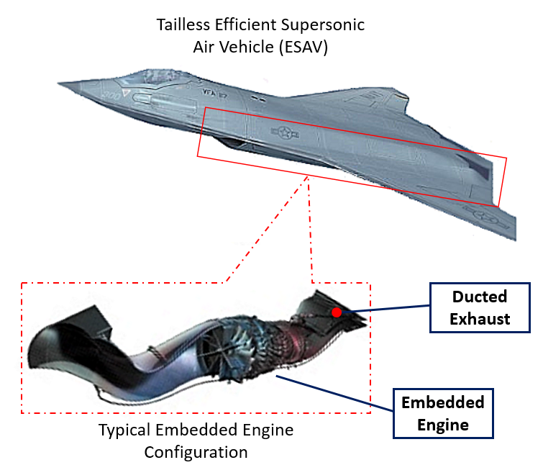

**Figure 1**: Tailless embedded engine configuration for a typical ESAV configuration. Expanded view shows the embedded engine configuration in more detail.

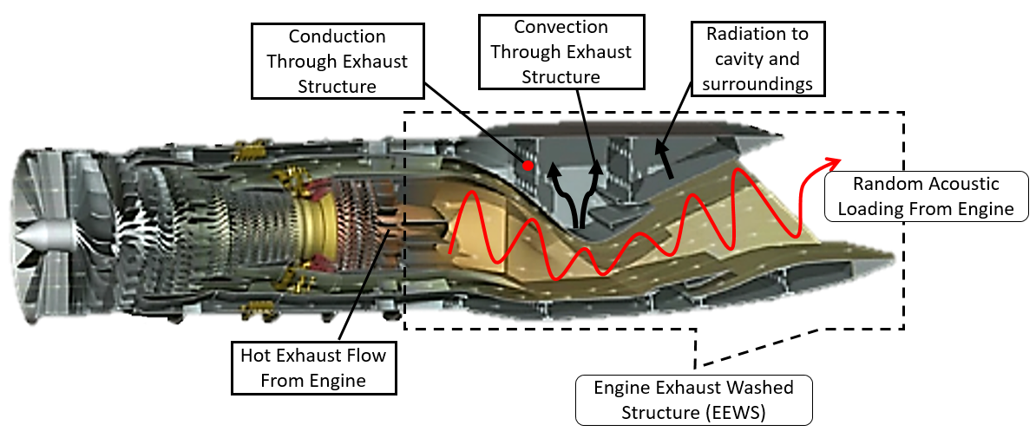

**Figure 2**: Acoustic and thermal loading environments often present in embedded engine configuration, which acts on the exhaust washed structure (EEWS)

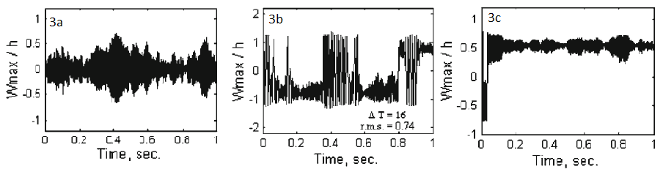

**Figure 3**: Dynamic response of aluminum panels subjected to thermal loading. 3a) non-buckled panel subject to acoustic loading. 3b) Post-buckled panel showing snap-though. 3c) Post-buckled panel vibrating about a buckled position.

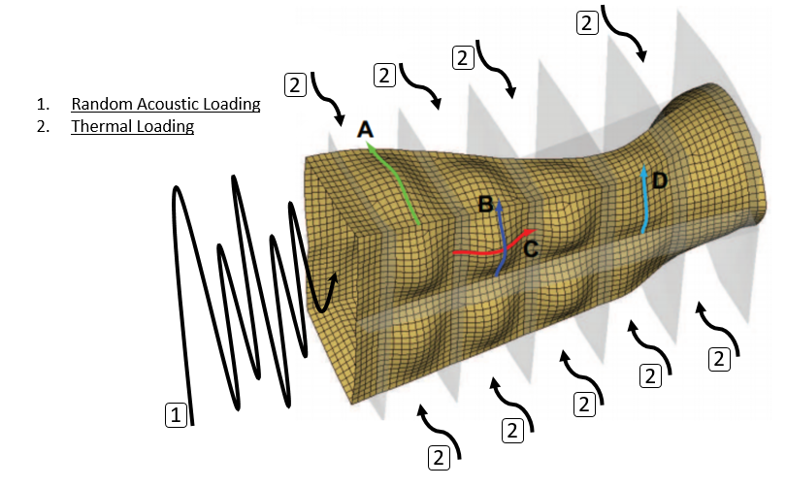

**Figure 4**: Deformation of the EEWS structure due to thermal expansion. Superimposed random acoustic loads with excite the thermally expanded structure, which drive a dynamics response at numerous excitation frequencies.

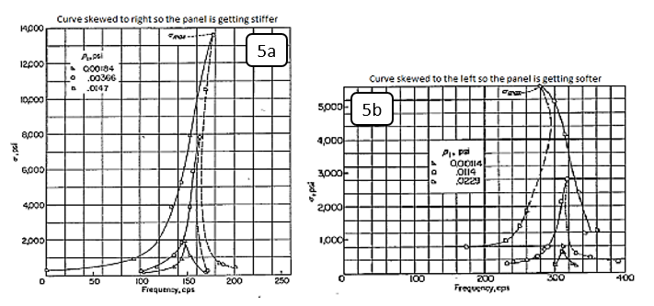

**Figure 5**: Asymmetric frequency response cures due to increased sound pressure levels. Figure on the left (5a) shows a response with increasing stiffness. Figure on the right shows a response with decreasing stiffness (5b)

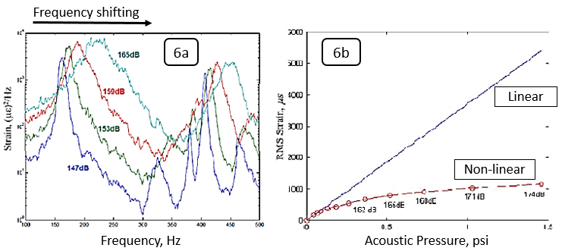

**Figure 6**: Frequency response function peak shifts and broadening due to nonlinear effects. Figure 6a shows non-linear effects on the frequency response. Figure 6b shows non-linear effects on strain estimations.